Name: | __________________________________________ | Date: 28/5/20
 | Year 9 Mathematics 2020  Total Marks:  /50  %  Test: PYTHAGORAS  Time allowed: 50 minutes  Calculators allowed  Resources Allowed:  - 1 piece of A4 paper notes, back and front, typed or handwritten  - Pens (blue/black preferred), pencils (including coloured), sharpener, correction fluid/tape, eraser, ruler, highlighters  - Show all your working clearly. Your working should be in sufficient detail to allow your answers to be checked readily and for marks to be awarded for reasoning. Incorrect answers given without supporting reasoning cannot be allocated any marks. For any question or part question worth more than two marks, valid working or justification is required to receive full marks.  - Use blue or black pen only please. Use pencil only for diagrams.

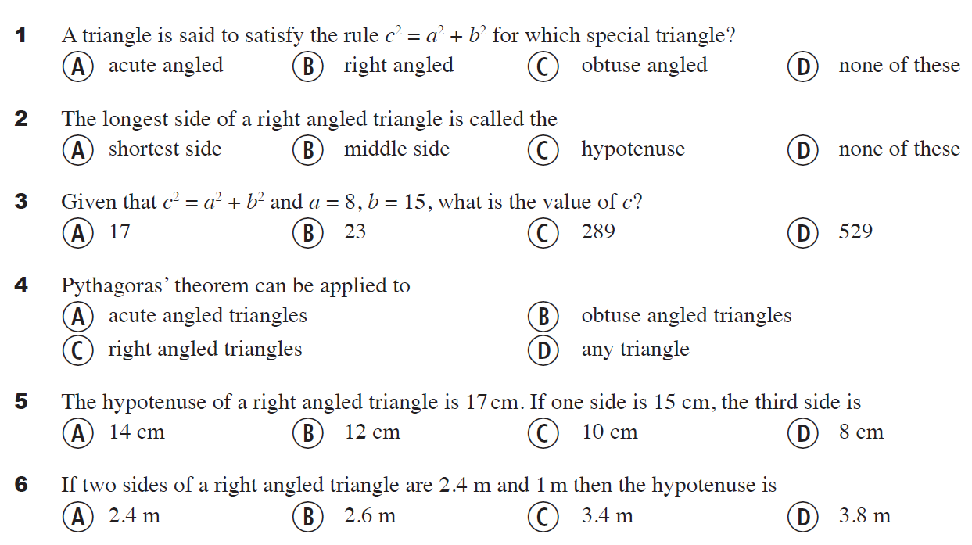
Multiple Choice: Circle the correct answer(s) (15 marks)
If two sides of a right angled triangle are 9 cm and 12cm then the hypotenuse is
- 30cm b) 15cm c) 81cm d) 144cm
The hypotenuse of a right angled triangle is 10cm. If one side is 6cm, the third side is
- 16cm b) 8cm c) 5cm d) 100cm
Given that c² = a² + b² and a = 3, b =4 what is the value of c?
- 25 b) 9 c) 5 d) 16

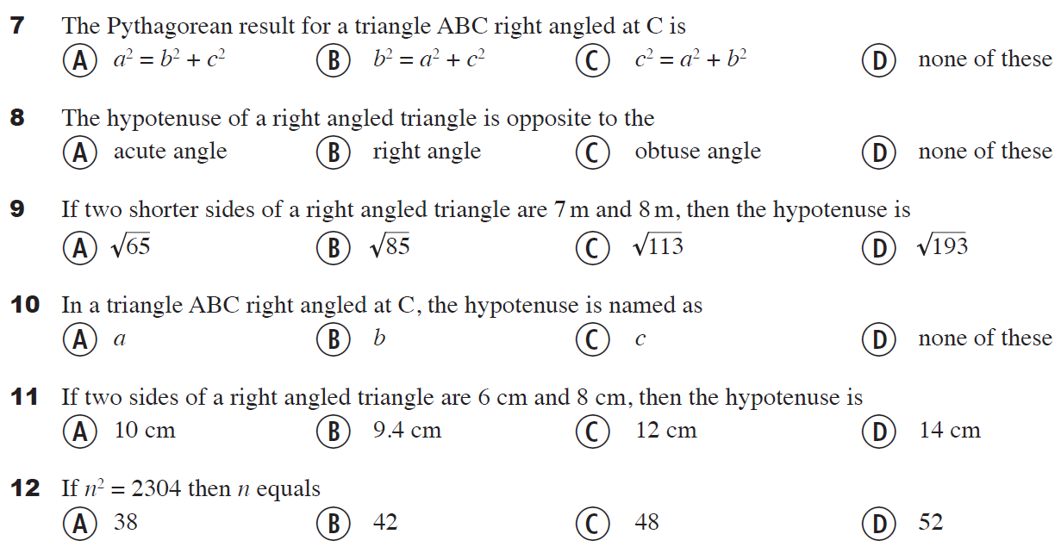
If two sides of a right angled triangle are 15 cm and 20cm then the hypotenuse is
- 25cm b) 40cm c) 35cm d) 26cm
If two sides of a right angled triangle are 16 cm and 12cm then the hypotenuse is
- 18cm b) 144cm c) 256cm d) 20cm

13 11² equals
- 112 b) 132 c) 121 d) 144

14 2.7² equals
- 2.7 x 2.7 b) $\frac{{27}^{2}}{{10}^{2}}$ c) 7.29 d) All of these

15 $\sqrt{81}$ equals
a) 9.0 b) 9² c) 9 d) $\frac{27}{3}$

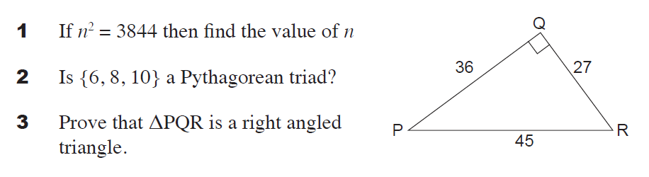
SHORT ANSWER (35 marks)

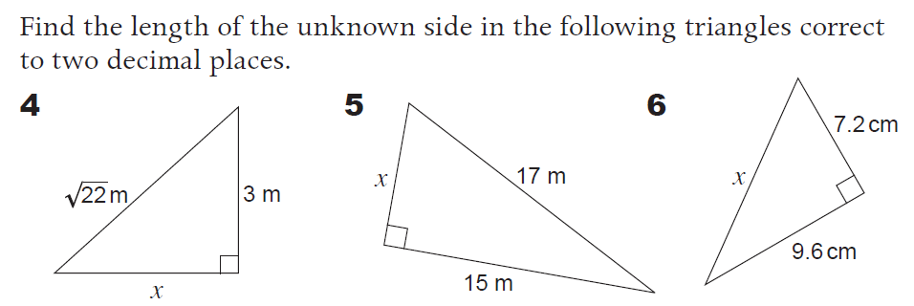

7
A square sheet of corrugated cardboard has a perforated diagonal measuring 10 cm in length. Find the length of the square (to 2 decimal places). First, draw and label a diagram.

8
A ship leaves port and sails 35 km due North and then 20 km due East. If the ship returns to port by travelling along the diagonal route, how many km (to the nearest km) would the ship have sailed altogether? First, draw and label a diagram.

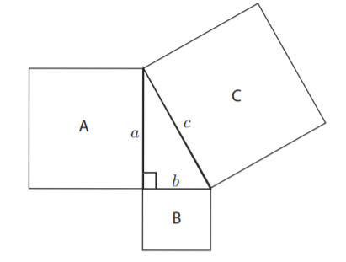
9
If the area of square A is 144cm² and the area of square B is 256cm². What is the length of side c?

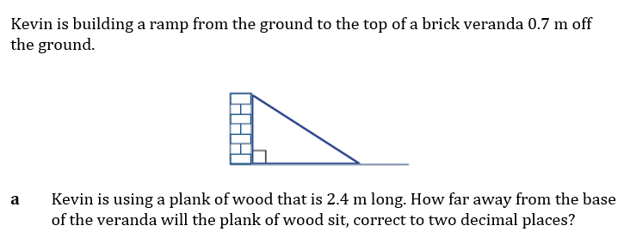
10
- Label the diagram with all known measurements.

b)

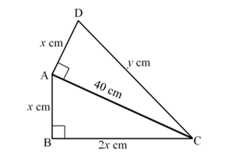
11

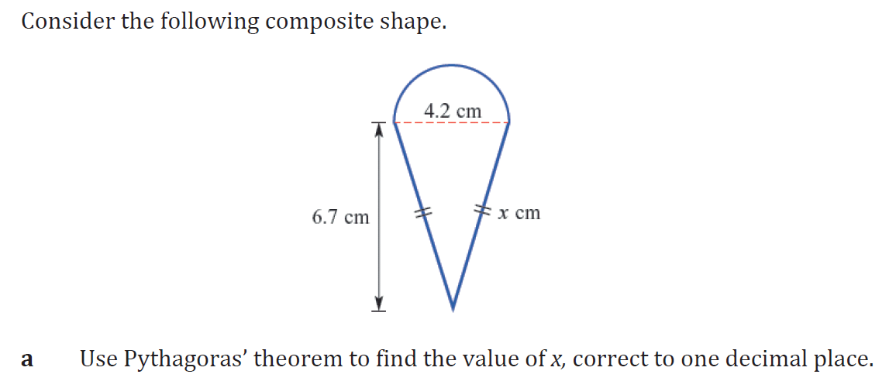
12

